1. Write a program to implement single Link List (with function insertion at first node, insertion at last node, insertion and deletion at middle node and traversing of link list after each node insertion).

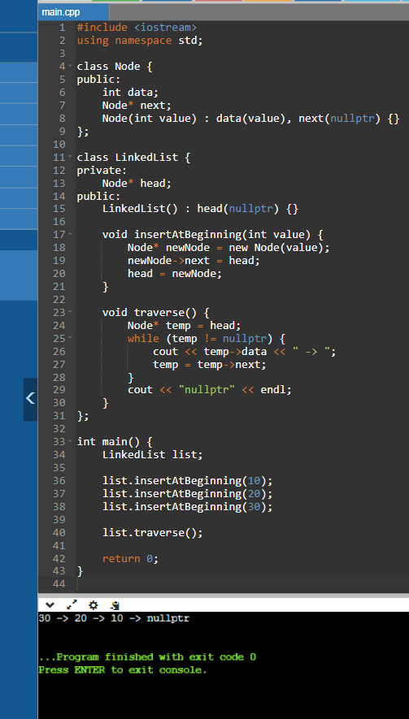

2.Write a program to implement single Link List (with function deletion at first node, deletion at last node, and deletion at middle node and traversing of link list after each node deletion

